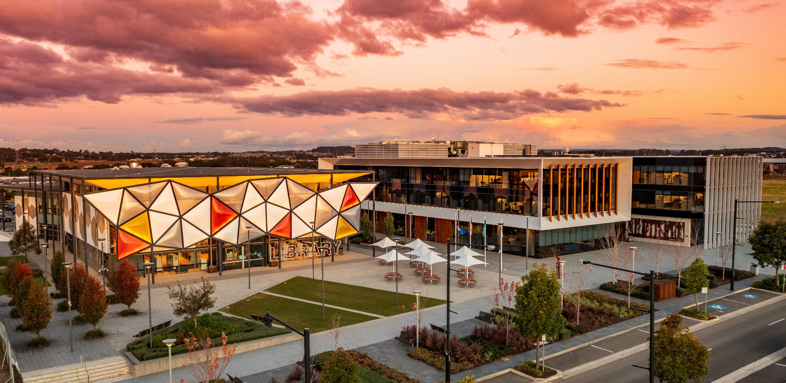
Camden Council Planning Proposal
Tranche 41 – Part Pondicherry
Version 5
October 2021

Document Register
Version | Date | Detail | Council Reference
1 | July 2020 | Original Planning Proposal lodged by proponent | 20/224456
2 | September 2020 | Revised Planning Proposal prepared by proponent | 20/317767
3 | December 2020 | Revised Planning Proposal submitted by Council for Gateway Determination | 20/416827
4 | June 2021 | Revised Planning Proposal prepared by Council for Public Exhibition | 21/79381
5 | October 2021 | Revised Planning Proposal prepared by Council for Finalisation | 21/448242

Executive Summary 4
Introduction 4
Part 1 – Objectives and Intended Outcomes 6
1.1 Overview 6
1.2 Site Locality and Context 7
Part 2 – Explanation of Provisions 9
2.1 Zoning 9
2.2 Other Controls 11
Part 3 – Justification 19
3.1 Section A – Need for the Planning Proposal 19
3.2 Section B – Relationship to Strategic Planning Framework 22
3.3 Section C – Environmental, Social and Economic Impact 29
3.4 Section D – State and Commonwealth Interests 33
Part 4 – Mapping 34
Part 5 – Community Consultation 35
Part 6 – Project Timeline 37
Part 7 – Conclusion 38
Part 8 – Appendices 39
Appendix 1: Consistency against State Environmental Planning Policies 40
Appendix 2: s9.1 Directions 44

Executive Summary

The subject site is located within the south-west portion of Pondicherry within the South West Growth Area (SWGA). Access to the site will be provided through a sub-arterial road connecting from The Northern Road and a future extension of the South Circuit collector road from Oran Park to the south.
The Planning Proposal seeks to make an amendment to the zoning, height of building, special areas, floor space, residential density, heritage, land application, land reservation acquisition, native vegetation protection, riparian protection area and development control maps. This is to reflect proposed changes to zone boundaries as well as site -specific controls.
The Planning Proposal is accompanied by an amendment to the Camden Growth Centres DCP which proposes to insert a new schedule (Schedule 6) with site-specific controls.
11 agency submissions were received during public exhibition, raising a number of issues, with no objections.
Following public exhibition, amendments have been made to the draft Schedule 6 Growth Centres DCP. Revised street cross sections have been inserted into the draft DCP to support Council’s and Government’s strategic direction of increasing walkability and tree canopy. The draft DCP figures have also been amended to show the southern creek as a riparian corridor, and to better reflect areas of Aboriginal heritage, potential contamination, and noise impact.

Introduction
This Planning Proposal seeks to make amendments to the State Environmental Planning Policy (Sydney Region Growth Centres) 2006 (the Growth Centres SEPP) and Camden Local Environmental Plan 2010 to rezone the subject site from RU1 Primary Production to R2 Low Density Residential and E2 Environmental Conservation.
As a result, the proposal will facilitate the delivery of 470 residential lots (approximately), public open space and riparian corridors, and associated cycle and pedestrian pathways.
The subject site is located in the south west portion of the Pondicherry Precinct within the SWGA. The Planning Proposal is accompanied by amendments to the Camden Growth Centres DCP, specifically a new schedule 6 containing site-specific controls for Tranche 41.
The Planning Proposal has been prepared in accordance with Section 3.33 of the Environmental Planning and Assessment Act 1979 (EPAA 1979) and guidelines published by DPIE, namely ‘A guide to preparing Planning Proposals’ to ensure all matters requiring consideration are appropriately addressed.
This Planning Proposal explains the intent and justification for the amendments to the Growth Centres SEPP 2006, as it applies to the land.
At its meeting of 8 December 2020, Council considered a report on the Planning Proposal and draft DCP which are included in the Appendices. Council subsequently resolved to forward the Planning Proposal to DPIE for Gateway Determination.
The Planning Proposal received a positive Gateway Determination on 8 February 2021 (included as part of the planning proposal package).
The Planning Proposal was placed on public exhibition from 2 to 30 June 2021, and 11 agency submissions were received with no objections. Following public exhibition, the draft DCP (Schedule 6) has been amended to incorporate revised street cross sections that support increased walkability and tree canopy.
A Voluntary Planning Agreement (VPA) has also been executed for Tranche 41.

Part 1 – Objectives and Intended Outcomes

1.1 Overview
The key objective of this Planning Proposal is to amend the existing planning controls under the Camden LEP 2010 and Growth Centres SEPP 2006 for the subject site as follows:
- Amend the Land Zoning Map to rezone the site from RU1 Primary Production to R2 Low Density Residential and E2 Environmental Conservation.

- Amend the Height of Buildings Map to apply a maximum building height of J – 9.5m, which is appropriate given the low-density residential character envisioned for the site.

- Amend the Residential Density Map to apply a residential density of O-15 dw/ha, which is appropriate given the low-density residential character envisioned for the site.

- Amend the Native Vegetation Map to identify native vegetation areas within the site.

- Amend the Riparian Protection Area Map to identify riparian areas within the site, in particular the riparian area located along Catherine Creek to the south.

- Amend the Land Application, Precinct Boundary Special Areas, Land Reservation Acquisition, Floor Space, Heritage, Development Control and Minimum Lot Size Maps to identify the subject site as part of the South West Growth Centre and to identify the precinct boundaries of Pondicherry and South Creek West.
The intended outcome of this Planning Proposal is to facilitate urban development in the south-west portion of the Pondicherry Precinct which is located within the South West Growth Area. The proposal will facilitate the delivery of 470 residential lots (approximately), public open space and riparian corridors, and associated cycle and pedestrian pathways.

The objectives and intended outcomes of this Planning Proposal are to be achieved by an amendment to the Growth Centres SEPP and associated land use mapping provisions as follows:
- Land Zoning Map (Sheet LZN_003)
- Minimum Lot Size Map (Sheet LSZ_003)
- Height of Buildings Map (Sheet HOB_003)
- Residential Density Map (Sheet RDN_003)
- Native Vegetation Map (Sheet NVP_003)
- Riparian Protection Area Map (Sheet RPN_003)
- Land Application Map (Sheet LAP_003)
- Precinct Boundary Map (Sheet PCB_003)
- Special Areas Map (Sheet SAM_003)
- Land Reservation Acquisition Map (Sheet LAP_003)
- Floor Space Map (Sheet FSR_003)
- Heritage Map (Sheet HER_003)
- Development Control Map (Sheet DVC_003)
An explanation of the proposed amendments to these maps is provided in Section 2.

1.2 Site Locality and Context
The site is located at 600J and 650 The Northern Road, Oran Park with the lots legally described as Lot 53 DP1259061 and Lot 9098 DP1274778 respectively. The subject site is located within the south west portion of the Pondicherry Precinct within the SWGA as shown in Figure 1.
The subject site is approximately 41.28ha in area, is irregular in shape, and slopes to the south east. The site is currently an open, pastoral landscape that is predominantly cleared of native vegetation. A 60m wide Transgrid powerline easement crosses the site in an east-west direction. An Endeavour Energy powerline easement (variable width) follows the alignment of The Northern Road.
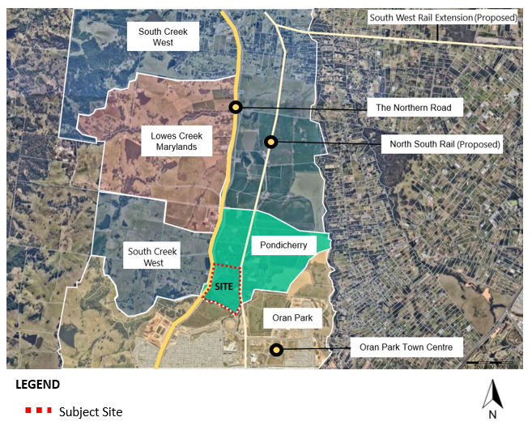
Figure 1: Subject Site

The surrounding land uses comprise of future employment lands (proposed) and Jack Brabham Reserve in Oran Park to the south, future Northern Neighbourhood Centre to the west and future residential dwellings to the north and east as part of broader Pondicherry. The site will be accessed via a sub-arterial road connecting from The Northern Road (arterial road), a roundabout intersection from Dick Johnson Drive (sub-arterial road) and a roundabout intersection from North Circuit (local road) as shown in Figure 2.
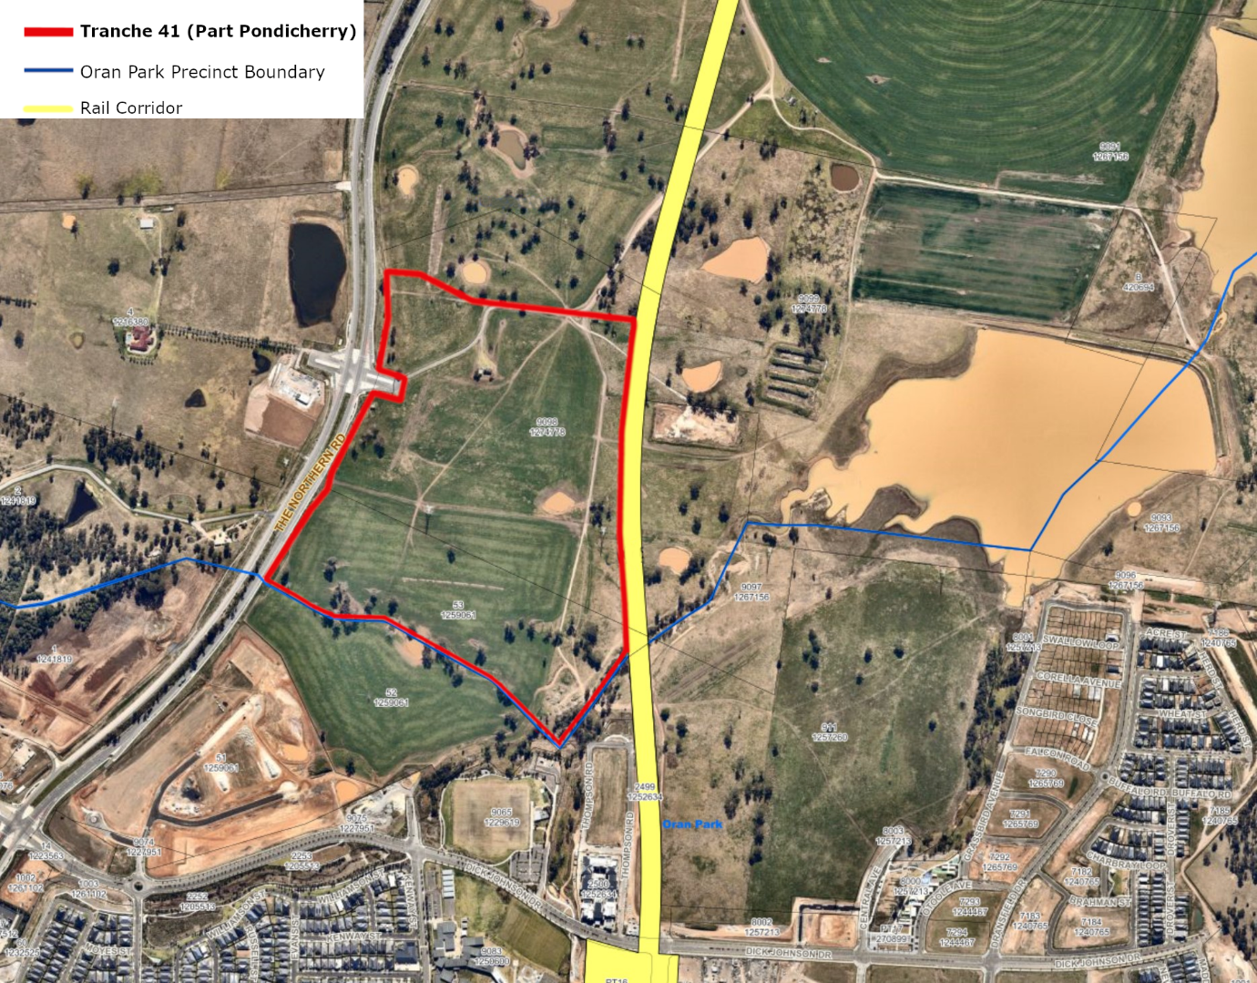
Figure 2: Site Context Map

Part 2 – Explanation of Provisions

2.1 Zoning

The site is currently zoned RU1 Primary Production under the Camden LEP. The Planning Proposal seeks to rezone the site from RU1 Primary Production to R2 Low Density Residential and E2 Environmental Conservation under the Growth Centres SEPP. The area of the site proposed to be rezoned from RU1 Primary Production to R2 Low Density Residential and E2 Environmental Conservation is outlined in red in Figure 3.

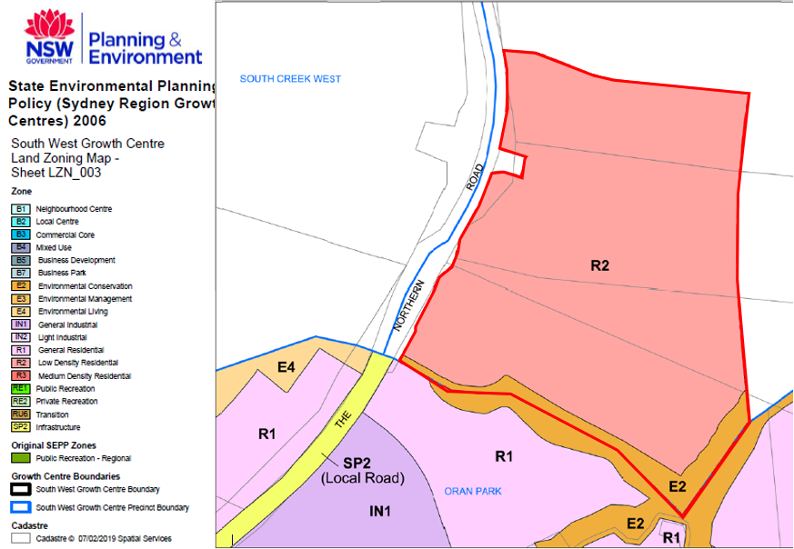
Figure 3: Proposed Zoning Map
Extracts of the R2 Low Density Residential and E2 Environmental Conservation land use table are provided below.
E2 Environmental Conservation
2 Permitted without consent
Nil
3 Permitted with consent
Drainage; Environmental facilities; Environmental protection works; Flood mitigation works; Information and education facilities; Kiosks; Recreation areas; Research stations; Roads; Signage; Waterbodies (artificial)
4 Prohibited
Business premises; Hotel or motel accommodation; Industries; Multi dwelling housing; Recreation facilities (major); Residential flat buildings; Restricted premises; Retail premises; Seniors housing; Service stations; Warehouse or distribution centres; Any other development not specified in item 2 or 3

R2 Low Density Residential
2 Permitted without consent
Home-based child care; Home occupations
3 Permitted with consent
Bed and breakfast accommodation; Boarding houses; Business identification signs; Centre-based child care facilities; Community facilities; Drainage; Dual occupancies; Dwelling houses; Earthworks; Educational establishments; Environmental facilities; Environmental protection works; Exhibition homes; Exhibition villages; Flood mitigation works; Group homes; Health consulting rooms; Home businesses; Home industries; Information and education facilities; Neighbourhood shops; Places of public worship; Recreation areas; Recreation facilities (indoor); Recreation facilities (outdoor); Roads; Secondary dwellings; Semi-detached dwellings; Seniors housing; Shop top housing; Studio dwellings; Veterinary hospitals; Waterbodies (artificial)
4 Prohibited
Any development not specified in item 2 or 3

Consistency with the Zone Objectives
E2 Environmental Conservation
1 Objectives of zone
- To protect, manage and restore areas of high ecological, scientific, cultural or aesthetic values.
- To prevent development that could destroy, damage or otherwise have an adverse effect on those values.

R2 Low Density Residential
1 Objectives of zone
- To provide for the housing needs of the community within a low density residential environment.
- To enable other land uses that provide facilities or services to meet the day to day needs of residents.
- To allow people to carry out a reasonable range of activities from their homes where such activities are not likely to adversely affect the living environment of neighbours.
- To support the well-being of the community by enabling educational, recreational, community, religious and other activities where compatible with the amenity of a low density residential environment.
- To provide a diverse range of housing types to meet community housing needs within a low density residential environment.

This Planning Proposal is consistent with the relevant objectives of the E2 Environmental Conservation zone for the following reasons:
- The proposal will facilitate the protection and restoration of ecological values through the conservation of riparian corridors within the subject site.
- The proposal will prevent development that could destroy, damage or have an adverse impact on ecological values through the zoning of the riparian corridor and native vegetation areas as environmental conservation areas.
This Planning Proposal is generally consistent with the relevant objectives of the R2 Low Density Residential zone, for the following reasons:
- The proposal will provide for the housing needs of the community by facilitating the delivery of up to 470 residential lots.
- The proposal will support the wellbeing of the community by providing other amenities such as open space and recreational areas within walking distance of their homes.
- The proposal will contribute to a diverse range of housing types in the Camden LGA by facilitating dual occupancies, dwelling houses and secondary dwellings in the locality.

2.2 Other Controls

As the Planning Proposal seeks to amend zoning boundaries, it also seeks to amend other relevant planning controls applying to the subject site.
The proposal seeks to apply the maximum building height of J- 9.5m for all development. This is to reflect the permitted height for development in the neighbouring Oran Park Precinct. While Oran Park also allows a 16m height limit for Residential Flat Buildings, this is not considered appropriate in the context of the outcomes envisaged for Tranche 41 which will primarily comprise of low-density residential development.
The proposal seeks to apply a residential density of 0-15 dw/ha to the subject site. This is consistent with the average density currently applying to low density residential areas within the South West Growth Area such as the Catherine Fields (Part) Precinct.
The proposal seeks to map native vegetation areas for the subject site. This will prevent the clearing of native vegetation, and manage existing native vegetation in accordance with the relevant biodiversity measures of the Biodiversity Act 2016.
The proposal seeks to map the riparian protection area found along Catherine Creek to the south. Referred to as “Stream 1A” it is identified as a first order stream in the Riparian Assessment The Natural Resources Access Regulator’s (NRAR) submission on the Planning Proposal confirms Stream 1A should be mapped as a riparian corridor.
The proposal also seeks to amend the lot size, land application, precinct boundary, special areas, land reservation acquisition, floor space, heritage and development control maps, for the purpose of identifying the subject site as part of the South West Growth Centre and to identify the precinct boundaries of Pondicherry and South Creek West.
The proposal does not seek to apply a minimum lot size for the subject site. This is consistent with the approach adopted for the Catherine Fields (Part) Precinct. The Growth Centre SEPP development standards relating to lot size are found in Appendix 9 Camden Growth Centres Precinct Plan, Part 4, Clause 4.1 and are unaltered by this Planning Proposal.
Figures 4 to 8 provide the minimum lot size, height of building, residential density, native vegetation, and riparian protection area map extracts from the Growth Centres SEPP 2006.
Figures 9 to 15 provide the land application, precinct boundary, special areas, land reservation acquisition, floor space, heritage and development control maps.
Figure 16 provides the Indicative Layout Plan from the draft Pondicherry (Part) Precinct DCP.
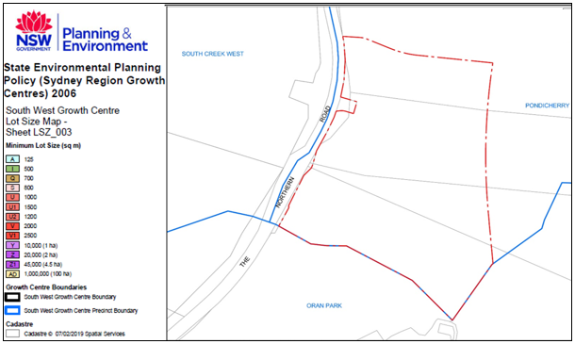Figure 4: Proposed Minimum Lot Size Map - Growth Centres SEPP 2006
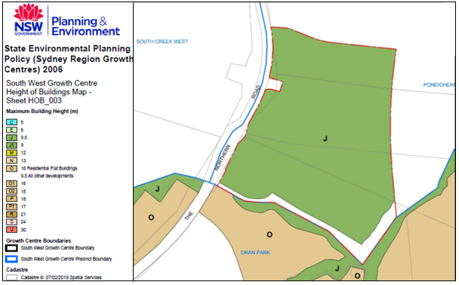Figure 5: Proposed Height of Buildings Map - Growth Centres SEPP 2006
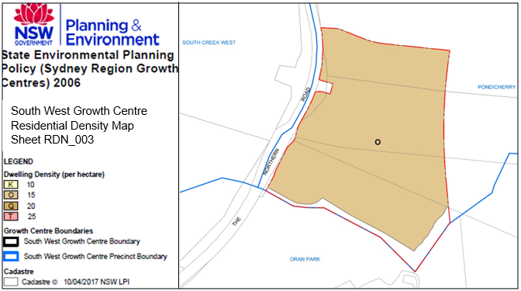Figure 6: Proposed Residential Density Map - Growth Centres SEPP 2006

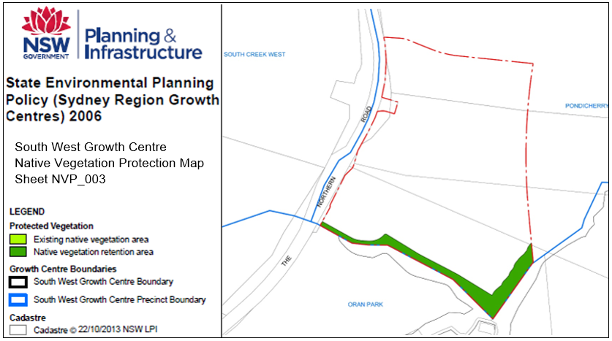Figure 7: Proposed Native Vegetation Protection Map - Growth Centres SEPP 2006
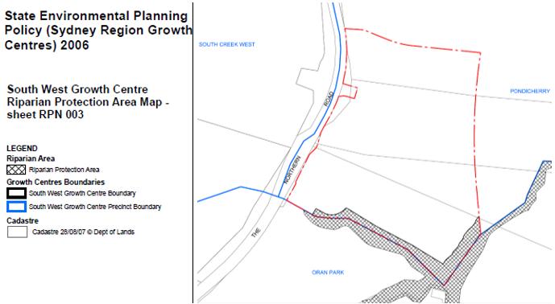Figure 8: Proposed Riparian Protection Map - Growth Centres SEPP 2006

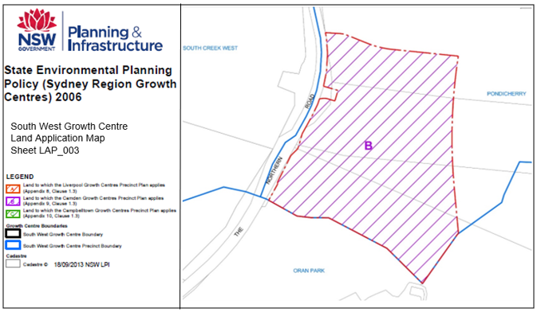Figure 9: Proposed Land Application Map - Growth Centres SEPP 2006
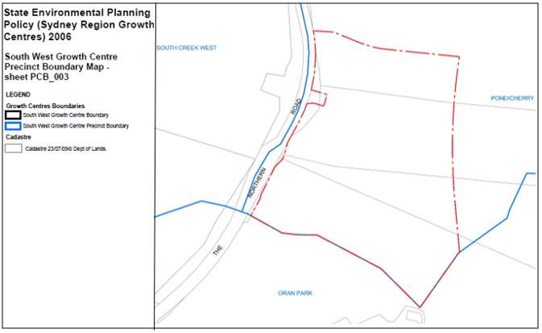Figure 10: Proposed Precinct Boundary Map - Growth Centres SEPP 2006

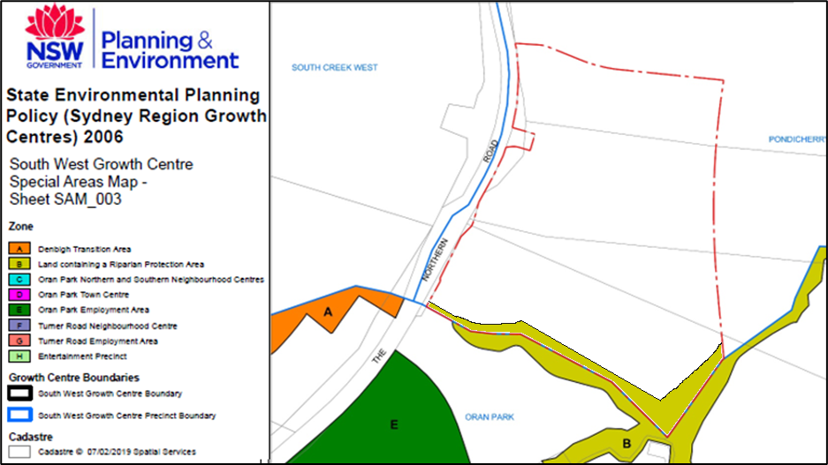Figure 11: Proposed Special Areas Map Extract - Growth Centres SEPP 2006
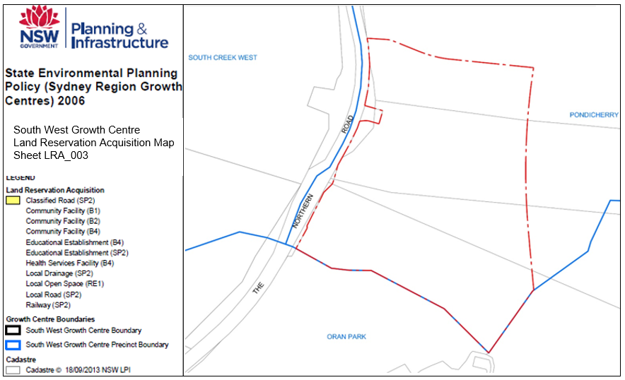Figure 12: Proposed Land Reservation Acquisition Map- Growth Centres SEPP 2006

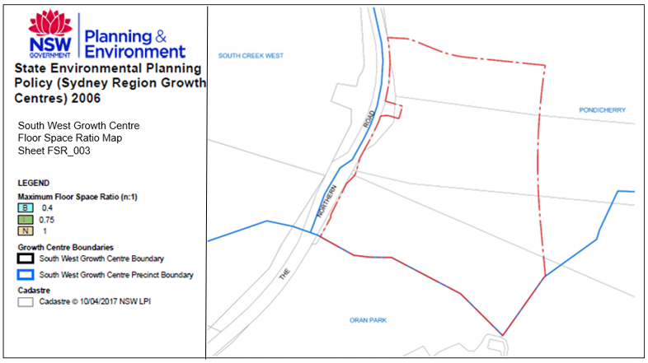Figure 13: Proposed Floor Space Ratio Map- Growth Centres SEPP 2006
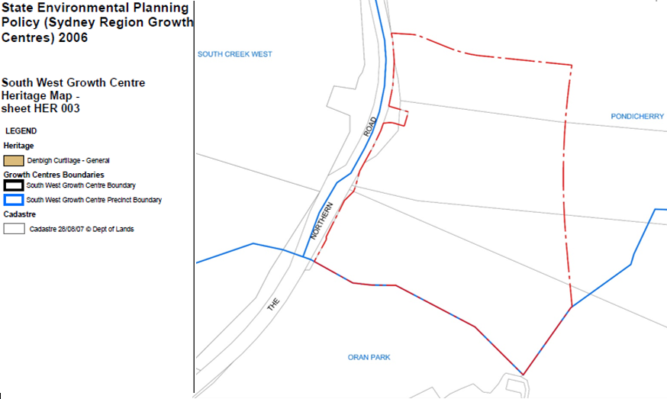Figure 14: Proposed Heritage Map - Growth Centres SEPP 2006

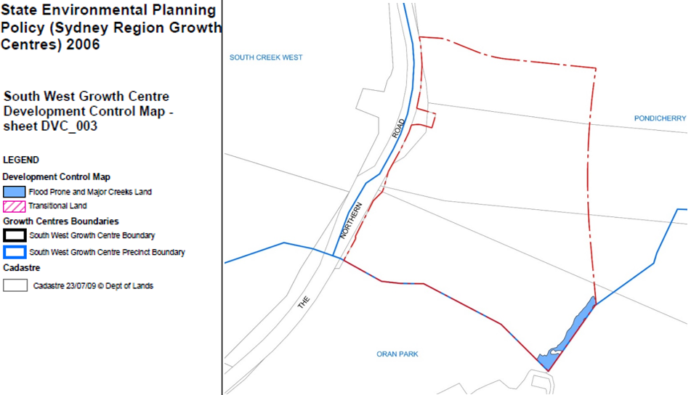Figure 15: Proposed Development Control Map Area - Growth Centres SEPP 2006
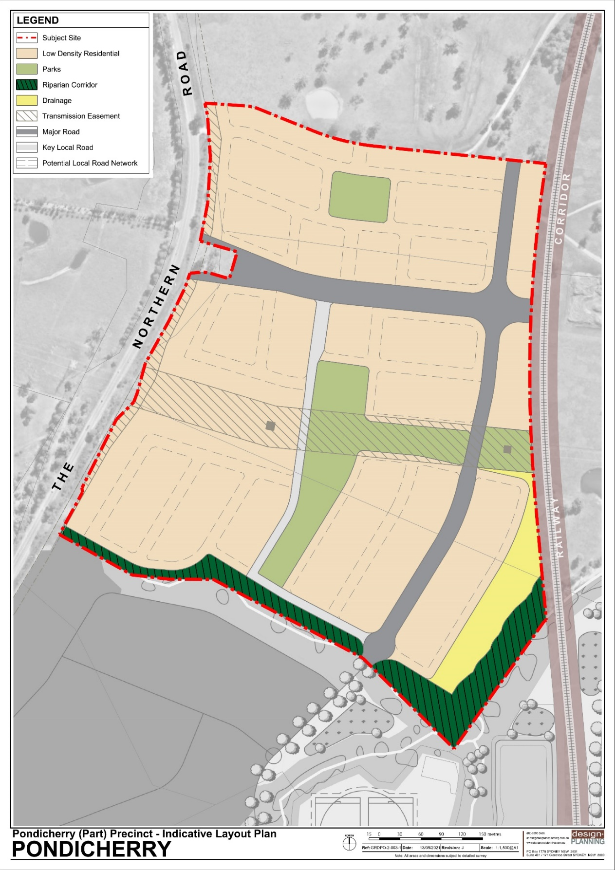
Figure 16: Indicative Layout Plan - Pondicherry (Part) Precinct DCP

Part 3 – Justification

3.1 Section A – Need for the Planning Proposal
Q1. Is the Planning Proposal a result of any strategic study or report?
This Planning Proposal is not a result of any Strategic Study or Report. Rather, the amendments proposed in this Planning Proposal are a result of the need to provide ongoing residential supply within the Camden LGA.
This Planning Proposal seeks to give effect to directions, strategies and actions outlined in local strategic plans and the NSW Governments recent strategic planning policies.
The Greater Sydney Region Plan – A Metropolis of Three Cities and Western City District Plan provides guidance for the management of growth within Sydney. The Planning Proposal seeks to facilitate urban development within Pondicherry within the South West Growth Area which has been earmarked as an appropriate area for urban growth.
Upon assessment, the amendments proposed by this Planning Proposal are considered to be consistent with the directions, strategies and actions outlined in local strategic plans and the NSW Government’s recent strategic planning policies.
A summary of key planning issues is provided below.
Provision of Active Open Space
The Planning Proposal is required to provide 2.13ha of active open space, however there is no proposed provision of active open space in Tranche 41. The Social Infrastructure Assessment (Assessment) does not recommend the on-site provision of active open space facilities in Tranche 41 as the site is not large enough to enable the clustering of sport courts/fields. The Assessment recommends contributions be made to additional future active open space within the Pondicherry Precinct and/or to embellish existing open space areas. In the long-term, it is planned that active open space will be provided in broader Pondicherry with a district sports facility to be located in the north-eastern portion of the precinct.
Provisions of Passive Open Space
The Planning Proposal previously identified the provision of passive open space adjacent to the Transgrid easement (referred to as ‘LP4’). Council officer and Panel advice recommended the relocation and consolidation of LP4 with other local neighbourhood parks to provide more usable public open space for the community. Accordingly, the proposal was revised to increase the usable area of the three neighbourhood parks in Tranche 41 (referred to as LP1, LP2, LP3 as identified in the draft DCP) which satisfactorily provides a cumulative total of 2.13 ha of passive open space.
Connectivity
It was noted that the neighbourhood park (LP3) in the northern portion of Tranche 41 is physically isolated from the open space network in the southern portion, with the sub-arterial road (Maryland Link Road No.1) presenting a barrier. Council officers and the Panel recommended the provision of high amenity connections between the open spaces within the northern and southern portion of Tranche 41 to better facilitate walkability and recreation.

Council officers have also worked with the proponent to improve the proposal’s overall street tree canopy and pedestrian/cyclist connectivity in accordance with Council’s and Government’s strategies. The draft DCP was amended to insert comprehensive street cross sections which included increased blisters, “flex zones” and dual footpaths. The draft DCP was also amended to reference the Pondicherry Tree Masterplan.
Land under the Transgrid Easement
A 60m wide transmission line easement crosses Tranche 41 in an east-west direction. The central and eastern portion of the easement is proposed to be embellished and dedicated to Council as a public park. The proponent has advised the western portion of the easement does not provide a logical extension of the proposed open space network and is intended to be in private ownership. There is precedent for subdivision of the easement under private lot ownership, with development consent having been granted for development adjacent to the transmission easement in the Catherine Fields (Part) Precinct.
While constrained by Transgrid requirements, the proposed park in the central and eastern portion will deliver share path connections to the broader open space network. The proposed dedication of the land to Council will be considered under Council’s Dedication of Constrained Lands Policy and relevant Transgrid requirements.
Water Cycle Management
Upon review of the Stormwater Management Report (Report), Council officers noted the Report needs to provide further detail to confirm if the proposed basins are adequately sized to ensure that post development levels of stormwater runoff will match pre-development levels. Council officers recommended the Report and associated modelling be revised to address this issue, and the Panel accepted this advice. As a result, the proponent has provided additional information including an annexure to the Report, and further flood modelling.
While the additional information provided assists in demonstrating stormwater attenuation via the two proposed basins, it does not fully meet Council’s stormwater requirements. Specifically, Council is currently undertaking a review of the Upper South Creek Flood Study as the floodplain risk management process in NSW requires continual review of existing studies. This study will confirm flood behaviour in the Upper South Creek catchment. The stormwater design will need to be consistent with the work undertaken as part of the Upper South Creek Flood Study review.
Voluntary Planning Agreement
A Voluntary Planning Agreement (VPA) has been executed by Council and the Proponent for Tranche 41. The VPA includes the delivery of passive open space; accessible riparian corridors; transport infrastructure; and drainage infrastructure. It also entails the provision of a shareway/pedestrian link between Tranche 41 and Jack Brabham Reserve and associated activity stations along the pedestrian link.
The VPA has a total value of $21,250,000, which includes $19,500,000 of land and works, and approximately $1,750,000 in monetary contributions. This includes a monetary contribution towards active open space facilities, with the first option entailing a monetary contribution to fund the district sports facility or the second option entailing a monetary contribution for the embellishment of existing open space within Jack Brabham Reserve.

Q2. Is the Planning Proposal the best way of achieving the objectives or intended outcomes, or is there a better way?
It is noted that the precinct planning process for Pondicherry is underway. The project is being managed under a ‘collaborative planning approach’ that was announced by the Minister for Planning and Public Spaces in November 2019 (currently led by the Department of Planning, Industry and Environment in collaboration with Council).
This Planning Proposal has been lodged to rezone the subject site located within the south-west portion of Pondicherry, to respond to the current demand for residential land.
The amendments to the Growth Centres SEPP and associated maps outlined under this Planning Proposal are the most appropriate and best means of achieving the objectives and intended outcomes. This is because the proposal is not reliant on the finalisation of studies relating to the broader Pondicherry precinct and therefore can provide an efficient response to the demand for residential land being experienced within the Camden LGA.
The Planning Proposal does not affect the broader collaborative precinct planning process for Pondicherry. However, it is acknowledged that the proposal has synergies to the design and planning being undertaken in broader Pondicherry and draws from precinct-wide specialist studies.
The proposed amendments to the SEPP Mapping will reflect the objectives and intended outcomes of this Planning Proposal which is primarily to facilitate urban development for part of Pondicherry within the SWGA.

3.2 Section B – Relationship to Strategic Planning Framework

Q3. Is the Planning Proposal consistent with the objectives and actions contained within the applicable regional or sub-regional strategy (including the Sydney Metropolitan Strategy and exhibited draft Strategies)?
A Metropolis of Three Cities - The Greater Sydney Region Plan (2018)
The Greater Sydney Region Plan (Region Plan) sets the vision, strategic directives and objectives for Greater Sydney.
The proposal is consistent with the relevant directions and objectives of the Region Plan as summarised below.
Direction 3: Infrastructure and Collaboration – A City supported by Infrastructure;
Objective 1: Services and infrastructure meet communities’ changing needs
The proposal seeks to catalyse continued infrastructure growth within the South West Growth Area (SWGA). This includes the addition of water, sewerage and electricity in areas which were not previously connected. The proposal also seeks to provide housing opportunities to support the SWGA and the future Western Sydney Airport.
Objective 2: Infrastructure aligns with forecast growth- growth infrastructure compact
The proposal seeks to facilitate up to 470 dwellings, with the site being located in the SWGA. The proposal will assist with the realisation of Council’s 6-10-year housing target.
Objective 3: Infrastructure adapts to meet future needs
The proposal seeks to provide key infrastructure including providing main roads which are bus capable. This will enable future public transport to utilise routes within Tranche 41 connecting to other areas of the SWGA.
Objective 5: Benefits of growth realised by collaboration of governments, community and business
The proposal seeks to provide housing in the SWGA. This will support surrounding businesses, the continued growth of Camden, and opportunities for housing near the Western Sydney Airport (WSA).
Direction 4: Liveability – Housing the City:
Objective 6: Services and infrastructure meet communities’ changing needs
The proposal seeks to provide open space and new housing opportunities which respond to the needs of the existing and new community in Oran Park and Pondicherry.
Objective 7: Communities are healthy, resilient and socially connected
The proposal seeks to provide different modes of travel throughout the Tranche 41. The ILP encourages pedestrian and cycle movement by providing well connected shared paths which connect to the wider Blue and Green Grid.
Objective 10: Greater Housing Supply
The proposal will facilitate up to 470 dwellings, with the site being located in the SWGA. The proposal will contribute to Council’s 6-10-year housing target. The proposal is consistent with this objective by providing additional housing opportunities in the right location.
Objective 12: Great Places that bring people together
The proposal seeks to provide good quality open spaces which will connect to broader Pondicherry. The broader precinct will provide a lake system and district playing field to create additional opportunities for the community to gather.
Direction 5: Productivity – A Well-Connected City;
Objective 14: A Metropolis of Three Cities – Integrated land use and transport creates walkable and 30 minute cities
Through the design of the roads and road network, the proposal seeks to ensure that the surrounding transport network including roads, active transport options and public transport forms an integrated road network.
Objective 17: Regional transport is integrated with land use
The proposed road network will link Tranche 41 to Oran Park via internal roads (future South Circuit road extension), as well as to the future WSA and Narellan Town Centre via The Northern Road. The proposal responds to existing plans for regional transport.
Objective 20: Western Sydney Airport and Badgerys Creek Aerotropolis are economic catalysts for Western Parkland City
The proposal is consistent with this objective by providing residential development to support the future WSA and Aerotropolis.
Direction 6: Sustainability – A City in its Landscape;
Objective 26: A Cool and Green Parkland City in the South Creek Corridor
Objective 27: Biodiversity is Protected, Urban Bushland and Remnant Vegetation is enhanced
The proposal is consistent with these objectives by providing and conserving the riparian corridors of Catherine Creek and Anthony Creek.
Objective 32: The Green Grid Links Parks, Open Spaces, Bushland and Walking and Cycling Paths
The proposal seeks to provide and enhance riparian corridors, provide shared and walking paths to link open spaces and provide links to broader Pondicherry which includes the preservation of the South Creek Corridor and enhancement of existing farm dams.
Western City District Plan (District Plan)
The Western City District Plan sets the planning priorities to deliver the vision, strategic directives and objectives for Western Sydney.
The proposal is consistent with the relevant objectives and planning priorities for Western City District Plan as summarised below.
Planning Priority W1- Planning for a city supported by infrastructure
The proposal will be well serviced by existing infrastructure and will leverage off the existing Town Centre and nearby open space facilities of Oran Park. Tranche 41 is also supported by an arterial road (The Northern Road) with regional access to the Aerotropolis, Campbelltown and Narellan.

Planning Priority W2 - Working through collaboration
Broader Pondicherry is being planned collaboratively with DPIE, Council and the landowner. The rezoning of Tranche 41 via this Planning Proposal is being considered as part of the broader collaborative planning process for Pondicherry and is also informing the process.
Planning Priority W3– Providing services and social infrastructure to meet people’s changing needs
The proposal will facilitate additional open space and housing to meet the needs of the community. It is noted that the community of Tranche 41 will also be able to access additional social infrastructure planned for broader Pondicherry and this includes a K-6 school, integrated neighbourhood and community centre and additional public open space.
Planning Priority W4- Fostering healthy, creative, culturally rich and socially connected communities
The proposal seeks to provide cycleways and shared paths to connect to the broader pedestrian/cycle network. This encourages healthier communities and wider regional connections throughout the Western Parkland City.
Planning Priority W5- Providing housing supply, choice and affordability, with access to jobs and services
The proposal seeks to provide housing near Oran Park, Aerotropolis, and Narellan. It also provides additional population to support local and regional commercial centres.
Planning Priority W6– Creating and renewing great places and local centres, and respecting the District’s heritage
The proposal seeks to provide opportunities to celebrate Aboriginal cultural heritage facilitated through provisions within the DCP.

Planning Priority W7 - Establishing the land use and transport structure to deliver a liveable, productive and sustainable Western Parkland City
The proposal ensures that surrounding roads, active transport and public transport are integrated with the proposed network of Tranche 41. This includes facilitating the delivery of a sub arterial road referred to as Maryland Link Road No. 1, which will be bus capable.
The proposed road network will link Tranche 41 to Oran Park via internal roads, as well as Narellan and the future WSA via The Northern Road.
Planning Priority W12 - Protecting and improving the health and enjoyment of the District’s waterways
Planning Priority W14- Protecting and enhancing bushland and biodiversity
The proposal seeks to preserve and enhance the riparian corridors of Catherine Creek and Anthony’s Creek. These riparian corridors also include the preservation of hollow bearing trees and dead stags which are important habitats for local wildlife.
Planning Priority W15- Increasing urban tree canopy cover and deliver Green Grid connections
The proposal seeks to increase urban tree canopy cover by providing street trees throughout Tranche 41. The proposal will also include additional areas of open space which will connect to the broader open space network throughout the Camden LGA.
Q4. Is the Planning Proposal consistent with the local council's Community Strategic Plan, or other local strategic plan?
Camden Local Strategic Planning Statement
The Camden Local Strategic Planning Statement (LSPS) is a 20-year planning vision, emphasising land use, transport and sustainability objectives to demonstrate how Camden LGA will change to meet the community’s needs over the next 20 years.

The proposal is consistent with the following Local Priorities and Actions of the LSPS:

Infrastructure and Collaboration Priority 1 – Aligning Infrastructure Delivery with Growth
The proposal is located in the SWGA which is designated for future urban growth. The proposal is consistent with this priority as it will facilitate further expansion of infrastructure, road upgrades and the further release of precincts.

Infrastructure and Collaboration Priority 2: Connecting Camden through Integrated Transport Solutions
The proposal is consistent with this priority by ensuring the surrounding transport network including roads, active transport and public transport is integrated into the proposed network of Tranche 41. This includes facilitating the delivery of Maryland Link Road No. 1, a sub arterial road which will be bus capable.
The proposed road network will link Tranche 41 to Oran Park via internal roads, as well as Narellan and the future WSA via The Northern Road in the Camden LGA.

Infrastructure and Collaboration Priority 3: Planning for the Delivery of the North South Rail and South West Rail Link Extension

The proposal adjoins the North South Rail corridor to the east. The ILP has been designed with consideration to the rail corridor and its future interface with adjoining residential development in Tranche 41.
Infrastructure and Collaboration Priority 4: Working in Partnership to Deliver a More Liveable, Productive and Sustainable Camden

Broader Pondicherry is being planned collaboratively with the Department of Planning Industry and Environment, Council and the landowner. The rezoning of Tranche 41 is being considered as part of the broader collaborative planning process for Pondicherry and is also informing the process.
Liveability Priority 1: Providing Housing Choice and Affordability for Camden’s Growing and Changing Population

The proposal is consistent with this local priority by providing additional housing to meet the needs of the growing community in the Camden LGA.
Sustainability Priority 1: Improving the Accessibility and Connectivity of Camden’s Green & Blue Grid and Delivering High Quality Open Space
The proposal is consistent with this local priority by designing a well-connected development which provides integrated shared and pedestrian paths to the broader network in the Camden LGA. In particular, the proposal provides walking tracks through the riparian corridor, which will connect to Oran Park as well as the active transport connections along The Northern Road.
Sustainability Priority 2: Protecting & Enhancing the Health of Camden’s Waterways, and Strengthening the Role and Prominence of the Nepean River
The proposal is consistent with this local priority by ensuring that the riparian corridors to the south of Tranche 41 are maintained and enhanced.

Sustainability Priority 6: Improving Camden’s Resilience to Natural Hazards and Extreme Weather Events
The proposal is consistent with this local priority by providing a well-designed stormwater management system which will ensure that stormwater run-off levels meet pre-development levels.
Community Strategic Plan (CSP)
The Community Strategic Plan (CSP) seeks to actively manage Camden LGA’s growth by retaining Camden’s heritage sites, scenic vistas and cultural landscapes. The Planning Proposal is consistent with the relevant directions of the CSP as summarised below.
Key Direction 1 – Actively Managing Camden LGA’s Growth
Strategy 1.1.1 – Ensure the provision of appropriate urban development for sustainable growth in the Camden LGA
The proposal is consistent with this direction as it will facilitate additional housing within the SWGA. The proposal will provide up to 470 dwellings and will be integrated with Oran Park.

Key Direction 2 – Healthy Urban and Natural Environment
Strategy 2.1.7– Ensure the long term assets of parks and open space is managed and maintained across the Camden LGA
The proposal is consistent with this direction as it will strengthen and enhance the existing natural environment by retaining riparian corridors and providing connectivity to the broader open space and Blue and Green Grid network.
Camden Local Housing Strategy
The Camden Local Housing Strategy (LHS) sets out a clear plan for housing in the Camden LGA over the next 10 to 20 years. The LHS was adopted by Council on 12 October 2021.
The proposal has been assessed against the Priorities, Objectives and Actions of the LHS and is consistent with the following Local Priorities:
Priority 1- Providing housing capacity and coordinating growth with infrastructure
Objective 1- Providing housing capacity and coordinating growth with infrastructure
The proposal is consistent with this objective as it seeks to provide housing capacity in Pondicherry within the South West Growth Area as identified in the strategy. The provision of this housing aligns with the availability of infrastructure, building on the existing service infrastructure in Oran Park to the south.
Objective 2- Precincts in the SWGA are planned and released to align with infrastructure provision
The proposal is consistent with this objective as it is supported by consultation with service providers. It will also leverage off existing and future transport opportunities (i.e. access to train and bus services) due to its proximity to Oran Park and The Northern Road.
Priority 2- Delivering resilient, healthy and connected communities
Objective 4 - Neighbourhood design supports healthy and connected communities that are better placed
The proposal is consistent with this objective as it delivers a neighbourhood design that will support a healthy and connected community within Tranche 41. The proposed movement network provides north-south and east-west connections, encouraging walkability to open space and riparian areas such as Jack Brabham Reserve and key destinations such as the Oran Park Employment Area and Oran Park Town Centre.
Objective 5 - Increase Camden LGA’s green cover and urban tree canopy
The proposal is consistent with this objective as it seeks to increase the green cover and urban tree canopy in the LGA. Specifically, it recognises and preserves native vegetation along the riparian corridor which will be subject to future embellishment. The proposal also incorporates “green links” between open space areas, which accommodates a wider verge with a sharepath and additional urban canopy.
Priority 3 - Delivering the right housing in the right location
Objective 6 - Housing density is strategically located to activate town centres, promote walkability and optimise infrastructure
The proposal is consistent with this priority as it seeks to deliver the right housing in the right location. While the proposal primarily delivers low-density detached housing, it reflects the broader precinct strategy which is to locate higher density residential development around core areas of high amenity (e.g. neighbourhood centre/lake precinct envisioned in the south-east portion of broader Pondicherry).
Priority 4 - Increasing housing choice and diversity
Objective 9- The mix of housing types matches the changing needs and preferences of the community
The proposal is consistent with this priority as it seeks to deliver housing types that match the needs and preferences of the community. The proposal will deliver 470 lots with lot sizes ranging between 300m² to 600m^{2.} This is consistent with draft housing analysis prepared for broader Pondicherry which identifies an approximate mix of 75% standard residential (lot size >300m²) and 25% medium density residential (lot size <300m²).
Q5. Is the Planning Proposal consistent with applicable state environmental planning policies?
The NSW Government has gazetted a range of State Environmental Planning Policies (SEPPs) and Sydney Regional Environmental Plans (SREPs or Deemed SEPPs) which guide land use and planning outcomes across the State and Sydney Metropolitan Region.
A review of the Planning Proposal and its intended outcomes and objectives against all relevant SEPPs is provided in the Appendices.
The review has demonstrated that the proposal is consistent with all relevant and applicable SEPPs.
Q6. Is the Planning Proposal consistent with applicable Ministerial Directions (Section 9.1 or formerly s.117 directions)?
The Planning Proposal is consistent with the Section 9.1 Directions by the Minister (formerly Section 117 Directions).
A review of the Planning Proposal and its intended outcomes and objectives against all current Ministerial Directions is provided in the Appendices.

3.3 Section C – Environmental, Social and Economic Impact

Q7. Is there any likelihood that critical habitat or threatened species, populations or ecological communities, or their habitats, will be adversely affected as a result of the proposal?
The site includes land currently zoned RU1 Primary Production. The site is currently an open, pastoral landscape that is predominantly cleared of native vegetation. It is noted that the site is subject to biodiversity certification under the Growth Centres SEPP which was gazetted on 14 December 2007.
Two native vegetation communities exist within Tranche 41: Shale Plains Woodland (part of the Cumberland Plain Woodland Vegetation Community) and Alluvial Woodland, which were found to be in poor and moderate condition respectively. Development impacts to native vegetation on the site is permitted under the Growth Centres Biodiversity Certification Order.
Ten hollow-bearing trees (HBTs) and a number of dead stags that have the potential to provide habitat for native fauna exist on the site. The proposed rezoning of riparian corridors from RU1 Primary Production to E2 Environmental Conservation may allow some of the HBTs to be retained on site and will lead to overall improved environmental outcomes for this land. Any potential removal of HBTs and stags as a result of development can be offset with nest boxes or rehoused hollows. This can be considered as part of any future development applications for subdivision works and facilitated through conditions of development consent.
In consideration of the above, it is considered that no critical habitat or threatened species, populations or ecological communities, or their habitats, will be adversely or unreasonably affected as a result of the Planning Proposal.
Q8. Are there any other likely environmental effects as a result of the Planning Proposal and how are they proposed to be managed?
Stormwater and Flooding
There will be no adverse stormwater and flooding impacts as a result of the proposed change in land use under this proposal. The Stormwater Report and associated modelling demonstrate that adequate stormwater infrastructure will be in place to mitigate stormwater impacts on the locality, with two proposed basins able to service the northern and southern catchment of Tranche 41.
It is noted that Council is currently undertaking a review of the Upper South Creek Flood Study as the floodplain risk management process in NSW requires continual review of existing studies. This study will confirm flood behaviour in the Upper South Creek catchment.
Further assessment has been undertaken to ensure that the stormwater design and modelling is consistent with the work undertaken as part of Council’s Upper South Creek Flood Study review.
Traffic Impacts
There will be no adverse traffic impacts as a result of the proposed change in land use under this proposal. The traffic report and associated modelling are satisfactory and conclude that there will be no unacceptable impacts on the road network in and surrounding Tranche 41, in particular the ‘gateway’ intersection of Maryland Link Road No.1 and The Northern Road.
The site will have suitable access points from The Northern Road (sub-arterial road) and the future South Circuit road extension (collector road) extending from Oran Park to the south.
Tranche 41 will also have convenient access to public transport in the long term, as it is located 1.6km from the future Oran Park train station and will have convenient access to bus stops along The Northern Road and within the site. South Circuit and Maryland Link Road No. 1 will both be bus capable with off-road share-paths. The proposed road designs comply with the minimum road width requirements provided in the Growth Centres DCP.
Aboriginal Heritage
One Aboriginal Archaeological site containing artefact scatter has been identified in Tranche 41 as having moderate archaeological significance. Based on the ILP, the site will be impacted by the proposed development.
To mitigate impacts on Aboriginal Archaeological sites, an Aboriginal Heritage Impact Permit (AHIP) will be required from Heritage NSW prior to any works being undertaken on the site. An application for an AHIP will need to detail recommended actions to be taken before, during and after an activity to manage and protect any Aboriginal objects and places.
To provide opportunities for the appreciation of the significance of the place, provisions have been included in the draft DCP requiring an Aboriginal Interpretation Plan to be submitted at the development application stage to detail ways for people to respect existing Aboriginal heritage.
Heritage NSW, in its submission to the public exhibition, recommended a comprehensive Aboriginal cultural heritage assessment report be prepared to support the planning proposal. This would address Ministerial Direction 2.3 Heritage Conservation and be consistent with the Western City District Plan.
The proponent (GDC) has provided Council officers with a comprehensive Aboriginal Cultural Heritage Assessment Report for Tranche 41 (dated December 2020) prepared by Kelleher Nightingale Consulting. A related Aboriginal Heritage Assessment (dated August 2020) has also been prepared for the broader Pondicherry Precinct (which includes Tranche 41). Furthermore, an Aboriginal Archaeological and Cultural Heritage Interpretation Plan (AACHIP) and an Aboriginal Archaeological Assessment is currently being prepared by Kelleher Nightingale Consulting as required by the draft DCP controls. Council officers have reviewed the documentation and believe it meets the Ministerial Direction and is consistent with the Western City District Plan. The updated documentation has been supplied to Heritage NSW.
Following public exhibition, the Aboriginal Cultural Heritage Figure in the draft DCP was amended to remove one area of potential archaeological significance (labelled “OPR- 9” in the Heritage Assessment). Further investigation found the area (OPR-9) is not located in Tranche 41 precinct. This amendment was supported by documentation provided by the proponent which has been reviewed by Council officers.
Riparian Corridor
There will be no adverse impacts on riparian corridors as a result of the proposed change in land use under this proposal.
Four first-order, two second-order and one third-order stream were located within Tranche 41 or within 40m of the site boundary. Of these, two of the higher order streams have distinctive bed, bank and aquatic habitat and are defined as a ‘river’ under the Water Management Act. Both streams are outside of Tranche 41.
Stream 1A also referred to as Catherine Creek, is located along the southern boundary of Tranche 41 and is not defined as a river. However, Catherine Creek is associated with a riparian protection area in Oran Park, and the report recommends that this creek be maintained and rehabilitated. NRAR, in its submission to the Planning Proposal, considers Stream 1A as a riparian corridor. This categorisation aligns with mapping shown in the Oran Park and Turner Road Waterfront Land Strategy 2009.The proposed zoning of Catherine Creek riparian corridor to E2 Environmental Conservation, and its identification on the riparian protection area map is also supported to mitigate any adverse impacts of future development on this riparian corridor.
Bushfire Risk
There will no adverse bushfire impacts on future development arising as a result of this proposal. The Bushfire Report concludes that the ILP can achieve the required bushfire protection measures. This is subject to suitable road dimensions, perimeter roads, Asset Protection Zones (APZs) and water supply being incorporated into the design of future development proposals.
Air Quality
An Air Quality Assessment (Assessment) identified four uses in the vicinity of the subject site that have the potential to impact on Tranche 41. These include the Hi-Quality Group at 761 The Northern Road Bringelly, a resource recovery and recycling plant, and three uses currently operating as part of the farming activities in Pondicherry. It has been assessed that these potential odour sources will not create odour to a level that would adversely impact on the amenity of future residents and impede the rezoning of Tranche 41.
Noise and Vibration Assessment
Four potential noise sources were identified as having potential impacts on Tranche 41. This includes traffic noise from The Northern Road, industrial noise from the future Oran Park Employment Area, rail noise and vibration, and potential aircraft noise.
Based on the submitted Noise and Vibration Assessment, there are adequate mechanisms are in place to mitigate adverse potential impacts relating to traffic, industrial and rail noise and vibration.
In terms of aircraft noise, the site is located outside of the ANEF 20 noise contours of Camden Airport and the future Western Sydney Airport. The site is located within the Obstacle Limit Surface (OLS) for the Western Sydney Airport. A control within State Environmental Planning Policy (Western Sydney Aerotropolis) 2020 requires certain types of development within the OLS to achieve indoor noise standards to mitigate the impact of future aircraft noise. Application of this control has been deferred to 26 April 2021, however future residential development within Tranche 41 will need to comply.
Following public exhibition, the Noise Impact Figure in the draft DCP was revised to exclude housing near the proposed Oran Park Employment Lands. Development in the Employment Lands will be required to address noise impacts in accordance with Council’s policies.
Q9. Has the Planning Proposal adequately addressed any social and economic effects?
Social Effects
The Planning Proposal will have positive social impacts on the locality, delivering additional housing and public open space to service residents, visitors and workforce of the Camden LGA. As further detailed in the submitted Social Infrastructure Assessment, this proposal will catalyse the provision of additional services including healthcare, aged care, child care, education, emergency services, community resources and playing fields to be delivered within the broader Pondicherry Precinct.
Economic Effects
The Planning Proposal will deliver increased housing supply which will support the planned centres and employment areas of the SWGA, in particular the adjacent precinct of Oran Park. The growing focus and Government commitment toward the Western Sydney Airport and anticipated infrastructure and jobs, is expected to catalyse population growth within the SWGA. The Planning Proposal will deliver additional housing to accommodate this growth.

3.4 Section D – State and Commonwealth Interests

Q10. Is there adequate public infrastructure for the Planning Proposal?
Tranche 41 will be adequately serviced by public infrastructure to meet the additional demand generated by the proposal. The site is well serviced by the surrounding upgraded arterial road network (The Northern Road) and essential services (water, sewer, telecommunications, gas, electrical) along with social infrastructure delivered within Oran Park.
The submitted Traffic Report demonstrated that the existing and future road network will accommodate the additional demand generated by the proposal. In particular, traffic modelling found that at full development (year 2036) the key intersection at The Northern Road and Maryland Link Road No.1 intersection would operate at acceptable service levels during the AM and PM peaks.
Furthermore, the submitted Stormwater Report also demonstrated that existing and planned stormwater infrastructure will be able to attenuate stormwater flows as a result of future development. Further assessment will be undertaken to ensure consistency with Council’s work that is emerging as part of the Upper South Creek Flood Study review.
Local passive open space will also be delivered to service the future community of Tranche 41. There is sufficient on-site provision of passive open space and arrangements in place to facilitate off-site provision of active open space (i.e. future district facility in the north-east portion of Pondicherry or the embellishment of nearby sporting facility at Jack Brabham Reserve).
A VPA worth a total value of $21,250,000 has been executed between Council and the proponent. It will deliver passive open space; accessible riparian corridors; transport infrastructure; and drainage infrastructure.

Q11. What are the views of State and Commonwealth public authorities consulted in accordance with the gateway determination?
No public authority objected to the Planning Proposal.

Part 4 – Mapping
The following maps in the Growth Centres SEPP 2006 are to be amended:
- Land Zoning Map (Sheet LZN_003)
- Minimum Lot Size Map (Sheet LSZ_003)
- Height of Buildings Map (Sheet HOB_003)
- Riparian Protection Area Map (Sheet RPN_003)
- Precinct Boundary Map (Sheet PCB_003)
- Special Areas Map (Sheet SAM_003)
- Heritage Map (Sheet HER_003)
- Development Control Map (Sheet DVC_003)
- Creation of a Residential Density Map (Sheet RDN_003)
- Creation of a Native Vegetation Protection Map (Sheet NVP_003)
- Creation of a Land Reservation Acquisition Map (Sheet LRA_003)
- Creation of a Floor Space Ratio Map (Sheet FSR_003)
- Creation of a Land Application Map (Sheet LAP_003)

Part 5 – Community Consultation
The Planning Proposal was placed on public exhibition from 2 to 30 June 2021. During the public exhibition period the Planning Proposal was available on Council’s website. A notification letter was also sent to landowners in the vicinity of the subject site to advise them of the Planning Proposal.
11 agency submissions were received during public exhibition, raising a number of issues, with no objections. No submissions from the community were received.
Council officers have assessed the matters raised in submissions and consulted with the proponent. A comprehensive overview of the submissions and responses is provided as an attachment.
The matters raised in the submissions related to the following themes:
- compliance with agency guidelines;
- biodiversity conservation;
- riparian protection;
- Aboriginal heritage;
- and transport connectivity.
Council officers determined the Proposal complied with all relevant agency guidelines (such as Transgrid, Endeavour Energy, Rural Fire Service and Sydney Water) and could be further addressed at DA stage if required. The EPA’s issue about odour impact was resolved by an updated Odour Impact Assessment which demonstrated the Proposal complied with the latest guidelines.
Environment, Energy and Science (EES) raised matters regarding biodiversity conservation and native vegetation. These are addressed by existing controls in the Growth Centres DCP, the Vegetation Management Plan (a requirement of a Voluntary Planning Agreement that has been entered into between Council and the proponent), and the Pondicherry Tree Masterplan. The draft DCP revised street cross sections also support greater tree plantings.
NRAR’s submission recommended the southern watercourse (stream 1A) be categorised as a riparian corridor. This is in accordance with the Oran Park and Turner Road Waterfront Land Strategy 2009 which shows the stream as a riparian corridor. The Indicative Layout Plan (ILP) has been amended to reflect this.
Heritage NSW requested additional information on the Proposal’s Aboriginal heritage impacts. The proponent’s consultant has provided further documentation, and it is considered the Proposal meets Ministerial Direction 2.3 Heritage Conversation.
Transport for NSW (TfNSW) raised matters regarding transport guideline compliance, traffic modelling, and active transport connectivity. These matters were addressed by providing further information to TfNSW (including traffic modelling) and inserting revised street cross sections into the Tranche 41 draft DCP.

Post Exhibition Tranche 41 draft DCP Amendments
Amendments have been made to the Tranche 41 draft DCP (Schedule 6) following public exhibition, in consultation with the proponent and DPIE. The amended draft DCP is provided as an attachment. The draft DCP is considered to be consistent with the intent of the Proposal endorsed by Council.
The draft DCP amendments include:
- updating the precinct vision;
- referencing supporting specialist studies;
- revising the ILP and DCP figures;
- amending electricity easement and rail corridor controls; and
- and inserting revised street tree cross sections.
DCP Section 2.1 Precinct Vision has been amended to note the focus on street tree canopy. The Pondicherry Tree Masterplan has also been referenced in the DCP to support its implementation in the DA process. The DCP amendments were made in response to EES’ submission, and Council’s and Government’s strategies in support of the green grid. The amended vision aligns with the revised street cross sections which support increased tree canopy.
DCP Section 2.2 Precinct Supporting Specialist Studies has been inserted following public exhibition. The inserted section lists the specialist studies (such as heritage and social infrastructure) that supported the Tranche 41 Planning Proposal. Listing the supporting specialist studies along with a hyperlink to them aligns the Tranche 41 DCP with the existing structure of the Camden DCP 2019 schedules.
DCP Section 2.3 Referenced Figures has been amended following public exhibition. Most notably the ILP has been revised to map the southern creek (“stream 1A”) as a riparian corridor. This is in accordance with the Oran Park and Turner Road Waterfront Land Strategy 2009 as referenced in NRAR’s submission. The Potential Contamination Risk and Noise Impact Areas figures have also been amended to better align with the supporting studies and Council policies. The Aboriginal Cultural Heritage figure has been revised to remove the cultural area OPR-9 as further investigation determined it is not located in the Tranche 41 precinct.
DCP Section 3.1 Development near or on Electricity Easements has been revised to consolidate Endeavour Energy and Transgrid controls into one section. A further control has been added to permit structures within the easement with the consent of the relevant authority. DCP Section 3.2 Development near or on the Rail Corridor has also amended to better reference noise guidelines in response to TfNSW’s submission.
DCP Section 3.3 Road Cross-Sections has been revised to incorporate additional cross sections for local streets, collector roads and sub arterial roads. These cross sections were the result of several collaborative workshops between Council specials officers (including from Assets and Traffic teams) and the proponent. They align with the draft Western Sydney Street Design Guidelines and the draft Western Sydney Street Engineering Specification. The cross sections implement Council’s and Government’s strategic directives (from the LSPS and District Plan) to increase tree canopy and pedestrian connectivity. The cross sections contain increased blisters (“flex zones”) which facilitate additional street tree plantings. The cross sections also mandate dual footpaths for local streets to increase accessibility. The revised cross sections are supported by TfNSW.

Part 6 – Project Timeline

Action | Timeframe
Date of Gateway Determination | 8 February 2021
Timeframe for the completion of required technical information | March– April 2021
Timeframe for government agency consultation (pre and post exhibition as required by Gateway Determination) | March – May 2021
Commencement and completion dates for public exhibition period | 2 June to 30 June 2021
Dates for public hearing (if required) | N/A
Timeframe for consideration of submissions | July - August 2021
Timeframe for the consideration of a proposal post-exhibition | September 2021
Submission to the department to finalise the LEP | November 2021
Anticipated date RPA will make the plan (if delegated) | N/A
Anticipated date RPA will forward to the department for notification | N/A

Part 7 – Conclusion

This Planning Proposal seeks to make amendments to the Camden Local Environmental Plan 2010 and State Environmental Planning Policy (Sydney Region Growth Centres) 2006 (the Growth Centres SEPP) to rezone the subject site from RU1 Primary Production to R2 Low Density Residential and E2 Environmental Conservation. This will facilitate the delivery of 470 residential lots (approximately), public open space and riparian corridors, and associated cycle and pedestrian pathways.
It is envisaged this Planning Proposal will enable development through the following amendments:
- Amend the Land Zoning Map to rezone the site from RU1 Primary Production to R2 Low Density Residential and E2 Environmental Conservation.

- Amend the Height of Buildings Map to apply a maximum building height of J – 9.5m, which is appropriate given the low-density residential character envisioned for the site.

- Amend the Riparian Protection Area Map to identify riparian areas within the site, in particular the riparian area located along Catherine Creek.

- Create a Residential Density Map to apply a residential density of 15 dw/ha, which is appropriate given the low-density residential character envisioned for the site.

- Create a Native Vegetation Protection Map to identify native vegetation areas within the subject site.

- Create a Land Reservation Acquisition Map, Floor Space Ratio Map and Land Application Map to identify the subject site as part of the South West Growth Centre and to identify the precinct boundaries of Pondicherry and South Creek West.

- Amend the Precinct Boundary, Special Areas, Heritage, Development Control and Minimum Lot Size Maps to identify the subject site as part of the South West Growth Centre and to identify the precinct boundaries of Pondicherry and South Creek West.
The Planning Proposal is considered to demonstrate merit in the following respects:
- The proposal will have no adverse economic, social and environmental impacts on the locality; and
- The proposal is consistent with region, district and local plans and their relevant objectives.
The Planning Proposal has been prepared in accordance with Section 3.33 of the EPAA 1979. Amendments to the Land Zoning Map (Sheet LZN_003), Height of Buildings Map (Sheet HOB_003), Riparian Protection Area Map (Sheet RPN_003), Precinct Boundary Map (Sheet PCB_003), Special Areas Map (Sheet SAM_003), Heritage Map (Sheet HER_003), Development Control Map (Sheet DVC_003) and Minimum Lot Size Map (Sheet LSZ_003); and the creation of a Residential Density Map (Sheet RDN_003), Native Vegetation Protection Map (Sheet NVP_003), Land Reservation Acquisition Map (Sheet LRA_003), Floor Space Ratio Map (Sheet FSR_003) and Land Application Map (Sheet LAP_003) represents the most appropriate method to achieve the objectives of this Planning Proposal.
The Planning Proposal will have a positive outcome for the community and complement the existing and future land use of the surrounding area.

Part 8 – Appendices

Appendix 1: Assessment against State Environmental Planning Policies
Appendix 2: Assessment against s9.1 Directions
Appendix 3: Draft Camden Growth Centres Development Control Plan Schedule 6
Appendix 4: Council Report and Minutes 8 December 2020
Appendix 5: Camden Local Planning Panel Minutes 20 September 2020
Appendix 6: Social Infrastructure Assessment
Appendix 7: Aboriginal Heritage Assessment
Appendix 8: Traffic Assessment
Appendix 9: Geotechnical Assessment
Appendix 10: Salinity Assessment
Appendix 11: Site Contamination Assessment
Appendix 12: Ecological Assessment
Appendix 13: Riparian Assessment
Appendix 14: Bushfire Assessment
Appendix 15: Infrastructure Servicing Report
Appendix 16: Air Quality Assessment
Appendix 17: Noise and Vibration Assessment

Appendix 1: Consistency against State Environmental Planning Policies

SEPP Title | Consistency | Comment
19. Bushland in Urban Areas | N/A | Not Applicable. There are no identified areas of urban bushland within the subject site.
21. Caravan Parks | N/A | Not Applicable. The Planning Proposal does not affect the operation of the SEPP.
33. Hazardous and Offensive Development | N/A | Not Applicable. The Planning Proposal does not affect the operation of the SEPP.
36. Manufactured Home Estates | N/A | Does not apply to the Camden LGA.
47. Moore Park Showground | N/A | Does not apply to the Camden LGA.
50. Canal Estate Development | N/A | Not applicable. The site is not within an area where canal development could occur.
55. Remediation of Land | Yes | Preliminary land capability studies have been undertaken as part of this proposal. Several ‘areas of environmental concern’ (AECs) were identified within the site and are reflected in relevant provisions of the draft DCP. Relevant AECs will be considered and remediated in accordance with the SEPP.
64. Advertising and Signage | Yes | The Planning Proposal does not affect the operation of the SEPP, with future signage proposals to be assessed against SEPP 64.
65. Design Quality of Residential Apartment Development | N/A | Not Applicable. Although the proposal contains zones where SEPP 65 would apply, the proposal primarily seeks to facilitate low density residential development.
70. Affordable Housing (Revised Schemes) | N/A | Not Applicable.
SEPP (Aboriginal Land) 2019 | N/A | Does not apply to Camden LGA.
SEPP (Affordable Rental Housing) 2009 | Yes | The proposal does not affect the operation of this SEPP.
SEPP (Building Sustainability Index: BASIX) 2004 | Yes | The SEPP would apply to future housing resulting from this proposal.
SEPP (Coastal Management) 2018 | N/A | Does not apply to the Camden LGA.
SEPP (Concurrences) 2018 | Yes | The Planning Proposal does not affect the operation of the SEPP. The Planning Secretary may act as concurrence authority where required.
SEPP (Educational Establishments and Child Care Facilities) 2017 | Yes | The Planning Proposal does not affect the operation of the SEPP.
SEPP (Exempt and Complying Development Codes) 2008 | Yes | The Planning Proposal does not affect the operation of the SEPP. Any future proposals identified in the SEPP (e.g. building alterations, change of use, etc.) will be required to comply with relevant provisions.
SEPP (Gosford City Centre) 2018 | N/A | Does not apply to the Camden LGA.
SEPP (Housing for Seniors or People with a Disability) 2004 | Yes | The proposal enables opportunities to provide housing in close proximity to amenities.
SEPP (Infrastructure) 2007 | Yes | Infrastructure can be provided in accordance with the objectives of the SEPP.
SEPP (Koala Habitat Protection) 2019 | N/A | Does not apply to the Camden LGA.
SEPP (Kosciuszko National Park-Alpine Resorts) 2007 | N/A | Does not apply to the Camden LGA.
SEPP (Kurnell Peninsula) 1989 | N/A | Does not apply to the Camden LGA.
SEPP (Mining, Petroleum Production and Extractive Industries) 2007 | Yes | The Planning Proposal does not prevent the application of the SEPP.
SEPP (Penrith Lakes Scheme) 1989 | N/A | Does not apply to the Camden LGA.
SEPP (Primary Production and Rural Development) 2019 | N/A | Not applicable. The site is within the SWGA and identified for future residential development.
SEPP (State and Regional Development) 2011 | N/A | Not applicable. The Planning Proposal does not prevent the application of this SEPP for state significant or critical infrastructure projects.
SEPP (State Significant Precincts) 2005 | N/A | Not applicable. The subject site does not constitute a State Significant Precinct as defined by the SEPP.
SEPP (Sydney Drinking Water Catchment) 2011 | N/A | The proposal does not contain any area within the drinking water catchment.
SEPP (Sydney Region Growth Centres) 2006 | Yes | The Planning Proposal site is located within Pondicherry Precinct within the SWGA.
SEPP (Three Ports) 2013 | N/A | Does not apply to the Camden LGA.
SEPP (Urban Renewal) 2010 | N/A | Does not apply to the Camden LGA.
SEPP (Vegetation in Non-Rural Area) 2017 | Yes | The Planning Proposal does not prevent the application of this SEPP.
SEPP (Western Sydney Employment Area) 2009 | N/A | Does not apply to the Camden LGA.
SEPP (Western Sydney Parklands) 2009 | N/A | Does not apply to the Camden LGA.
SEPP (Western Sydney Aerotropolis) 2020 | N/A | The Planning Proposal does not prevent the application of this SEPP.
SEPP (Major Infrastructure Corridors) 2020 | N/A | The Planning Proposal does not prevent the application of this SEPP.
SEPP (Activation Precincts) 2020 | N/A | Does not apply to Camden LGA.
Sydney Regional Environment Plan No 8 (Central Coast Plateau Areas) | N/A | Does not apply to the Camden LGA.
Sydney Regional Environment No 9 (Extractive Industry) | N/A | Not applicable.
Sydney Regional Environmental Plan No 16 (Walsh Bay) | N/A | Does not apply to the Camden LGA.
Sydney Regional Environmental Plan No 20 Hawkesbury-Nepean River | Yes | The Planning Proposal does not prevent the application of the SEPP to future development applications.
Sydney Regional Environmental Plan No 24—Homebush Bay Area | N/A | Does not apply to the Camden LGA.
Sydney Regional Environmental Plan No 26—City West | N/A | Does not apply to the Camden LGA.
Sydney Regional Environmental Plan No 30 St Marys | N/A | Does not apply to the Camden LGA.
Sydney Regional Environmental Plan No 33—Cooks Cove | N/A | Does not apply to the Camden LGA.
Sydney Regional Environmental Plan (Sydney Harbour Catchment) 2005 | N/A | Does not apply to the Camden LGA.

Appendix 2: s9.1 Directions

S9.1 Direction Title | Consistency | Comment
1.0 Employment and Resources
1.1 Business and Industrial Zones | N/A | No business or industrial zones are proposed as part of the Planning Proposal.
1.2 Rural Zones | No | The proposal will rezone existing rural land zoned RU1 Primary Production for residential purposes. The site is located within the SWGA and is identified for new housing through State and Local Government strategic policies and directions.
1.3 Mining, Petroleum Production and Extractive Industries | Yes | The Planning Proposal is consistent with this Ministerial Direction. The proposal is located within the South West Priority Area and is not within an area identified for future extractive industries.
1.4 Oyster Aquaculture | N/A | Does not apply to the Camden LGA.
1.5 Rural Lands | N/A | Not applicable as this Direction excludes land located within the Greater Sydney Region, which the subject site is located.
2.0 Environment and Heritage
2.1 Environment Protection Zones | Yes | The Planning Proposal is consistent with this Ministerial Direction. The proposal seeks to retain and enhance the environmentally sensitive creek corridors located within the site. These corridors will be identified and protected through the E2 Environmental Conservation zone and includes areas identified as Native Vegetation Retention. The vegetation within the corridor will be protected in accordance with the relevant Development Standards of the Growth Centre SEPP and Camden Growth Centres Precinct Plan.  The Planning Proposal is supported by a Terrestrial Ecological Analysis which provides an assessment of the biodiversity values of the site. Development impacts to native vegetation on the site is permitted under the Growth Centres Biodiversity Certification Order.
2.2 Coastal Protection | N/A | Does not apply to the Camden LGA.
2.3 Heritage Conservation | Yes | The Planning Proposal is consistent with this Ministerial Direction.  There are no sites of European Heritage significance located within the study area.  A comprehensive Aboriginal Cultural Heritage Assessment Report for Tranche 41 (dated December 2020) has been prepared by Kelleher Nightingale Consulting. A related Aboriginal Heritage Assessment (dated August 2020) has also been prepared for the broader Pondicherry Precinct (which includes Tranche 41). The assessments found that with appropriate management and/or mitigation, none of the identified Aboriginal heritage features found on site should prevent development of the Pondicherry Precinct.  Furthermore, an Aboriginal Archaeological and Cultural Heritage Interpretation Plan (AACHIP) and an Aboriginal Archaeological Assessment is currently being prepared by Kelleher Nightingale Consulting as required by the draft DCP controls.  Prior to any works being undertaken on the site, an Aboriginal Heritage Impact Permit (AHIP) will be required from Heritage NSW. An application for an AHIP will need to detail recommended actions to be taken before, during and after an activity to manage and protect any Aboriginal objects and places.
2.4 Recreation Vehicle Areas | N/A | Not Applicable as the proposal does not seek to introduce any recreational vehicle areas.
2.5 Application of E2 and E3 Zones and Environmental Overlays in Far North Coast LEPs | N/A | Does not apply to the Camden LGA.
2.6 Remediation of Contaminated Land | Yes | The Planning Proposal is consistent with this ministerial direction. A Contamination Report has been submitted to support the Planning Proposal. Overall, the contamination report provides recommendations for further site investigation, which will ensure that risk of harm to human health and the environment is considered in all stages of the planning process.  The ministerial direction applies as the subject site concerns land on which development for a purpose referred to in Table 1 to the contaminated land planning guidelines is being or is known to have been carried out. Based on the Contamination Report, it is known that the site was historically used for agricultural purposes.  The Contamination Report found that the potential for contamination constraints to the proposed redevelopment for the site excluding areas of environmental concern (AECs) is considered to be low. The potential for contamination constraints for identified AECs is considered to be low to medium.  It was recommended for a Detailed Site Investigation (DSI) to be carried out prior to subdivision, which should include targeted sampling of identified AECs and additional areas (e.g. previous dam site). This further assessment will determination appropriate remediation requirements (if any). Section 2.3.7 of the Camden Growth Centres DCP has controls to ensure that further investigation into contamination occurs at the DA stage. Further, the Tranche 41 DCP (Schedule) identifies the AECs identified in the Contamination Report.
3.0 Housing, Infrastructure and Urban Development
3.1 Residential Zones | Yes | The Proposal is consistent with the Ministerial Direction. The site is located within the SWGA and is identified for new housing through State and Local Government strategic policies and directions. Further, the Pondicherry (Part) Precinct will leverage the community infrastructure and services delivered through and around Oran Park ensuring minimal additional investment by Government and will contribute to the supply of new housing within an area of known current and future demand.
3.2 Caravan Parks and Manufactured Home Estates | N/A | Not Applicable. No caravan or manufactured home estates are proposed.
3.3 Home Occupations | N/A | Not applicable. As new dwellings are built and occupied, residents will have the option to pursue low-impact small businesses.
3.4 Integrating Land Use and Transport | Yes | The Planning Proposal is consistent with this Ministerial Direction. Road infrastructure within the site will be suitable for bus routes and pedestrian/cycle paths will link to surrounding residential areas.
3.5 Development Near Licensed Aerodromes | N/A | Not Applicable. The proposal is not within the vicinity of an existing licensed aerodrome.
3.6 Shooting Ranges | N/A | Not Applicable. There is no shooting range on the subject site.
3.7 Reduction in non-hosted short term rental accommodation period | N/A | Does not apply to the Camden LGA.
4.0 Hazard and Risk
4.1 Acid Sulphate Soils | N/A | Does not apply to the Camden LGA.
4.2 Mine Subsidence and Unstable Land | N/A | Does not apply to the Camden LGA.
4.3 Flood Prone Land | Yes | The Planning Proposal is consistent with this Ministerial Direction. The submitted Water Cycle Management Strategy prepared by Calibre Consulting assessed potential flood impacts of the proposal. While the site is partially flood affected, proposed drainage infrastructure will have the capacity to service the northern and southern catchment of Tranche 41. Potential flood impacts generated by development can be managed by providing a conventional street drainage and detention system prior to discharge into the adjacent creek network.
4.4 Planning for Bushfire Protection | Yes | The Planning Proposal is consistent with this Ministerial Direction as it demonstrates that bush fire hazard can be effectively managed to protect life, property and the environment.  Council consulted the Commissioner of the NSW Rural Fire Service (RFS) following receipt of the Gateway Determination.  On 17 March 2021, RFS provided a response, raising no objections to the proposal. This is subject to amending the document ‘Camden Growth Centre Precincts Development Control Plan – Schedule 6, Pondicherry Part Precinct’ (in particular Figure 2-6: Bushfire Risk and Asset Protection Zone requirements). Figure 2-6 of the DCP must be consistent with Figure 3- Preliminary bushfire hazard assessment and asset protection zones (APZ) of the Bushfire Assessment, prepared by Eco Logical Australia, dated 28 September 2020.  The proposed amendment to the DCP will ensure that all APZs relevant to the subject site are identified. The DCP has been amended accordingly to address comments issued by RFS.  As the temporary APZ to the north and east of the site also fall within the north-south rail corridor, this will require consultation with Transport for NSW prior to any works (e.g. perimeter road) being undertaken in the identified area.
5.0 Regional Planning
5.1 Implementation of Regional Strategies | N/A | Does not apply to the Camden LGA.
5.2 Sydney Drinking Water Catchments | N/A | Does not apply to the Camden LGA.
5.3 Farmland of State and Regional Significance on the NSW Far North Coast | N/A | Does not apply to the Camden LGA.
5.4 Commercial and Retail Development along the Pacific Highway, North Coast | N/A | Does not apply to the Camden LGA.
5.9 North West Rail Link Corridor Strategy | N/A | Does not apply to the Camden LGA.
5.10 Implementation of Regional Plans | Yes | The Planning Proposal is consistent with this Ministerial Direction. It has considered and is consistent with the directions of The Greater Sydney Region Plan (2018).
5.11 Development of Aboriginal Land Council land | N/A | The Planning Proposal site is not land identified within the Application Map of State Environmental Planning Policy (Aboriginal Land) 2019.
6.0 Local Plan Making
6.1 Approval and Referral Requirements | Yes | The Planning Proposal is consistent with this Ministerial Direction as it does not introduce any additional or new referral requirements.
6.2 Reserving Land for Public Purposes | Yes | The Planning Proposal is consistent with this direction as it will not require land for public purposes without the relevant authority’s consent.
6.3 Site Specific Provisions | Yes | The Planning Proposal is consistent with this direction as it does not seek to amend another environmental planning instrument to introduce site-specific provisions. All relevant provisions are proposed under the State Environmental Planning Policy (Sydney Region Growth Centres) 2006.
7.0 Metropolitan Plan Making
7.1 Implementation of A Plan for Growing Sydney | Yes | The Greater Sydney Commission released the Sydney Region Plan and Western City District Plan in 2018. This Planning Proposal has been assessed and is consistent with these documents.
7.3 Parramatta Road Corridor Urban Transformations Strategy | N/A | Does not apply to the Camden LGA.
7.4 Implementation of North West Priority Growth Area Land Use and Infrastructure Implementation Plan | N/A | Does not apply to the Camden LGA.
7.5 Implementation of Greater Parramatta Priority Growth Area Interim Land Use and Infrastructure Implementation Plan | N/A | Does not apply to the Camden LGA.
7.6 Implementation of Wilton Priority Growth Area Interim Land Use and Infrastructure Implementation Plan | N/A | Does not apply to the Camden LGA.
7.7 Implementation of Glenfield to Macarthur Urban Renewal Corridor | N/A | Does not apply to the Camden LGA.
7.8 Implementation of the Western Sydney Aerotropolis Plan | N/A | Not Applicable as the proposal site is not within the specified area.
7.9 Implementation of Bayside West Precincts 2036 Plan | N/A | Does not apply to the Camden LGA
7.10 Implementation of Planning Principles for the Cooks River Cove Precinct | N/A | Does not apply to the Camden LGA
7.11 Implementation of St Leonards and Crows Nest 2036 Plan | N/A | Does not apply to the Camden LGA
7.12 Implementation of Greater Macarthur 2040 | Yes | This planning proposal is generally consistent with this direction. The subject site is located within the South West Growth Area and will not have any impacts on the growth area precincts identified in the Greater Macarthur 2040.
7.13 Implementation of the Pyrmont Peninsula Place Strategy | N/A | Does not apply to the Camden LGA

